Debits and Credits
Debits and credits form the foundation of the accounting system. The mechanics of the system must be memorized. Once understood, you will be able to properly classify and enter transactions. These entries makeup the data used to prepare financial statements such as the balance sheet and income statement.
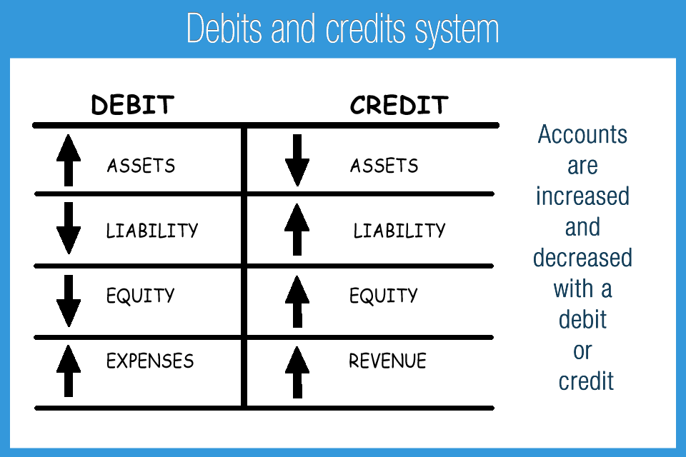
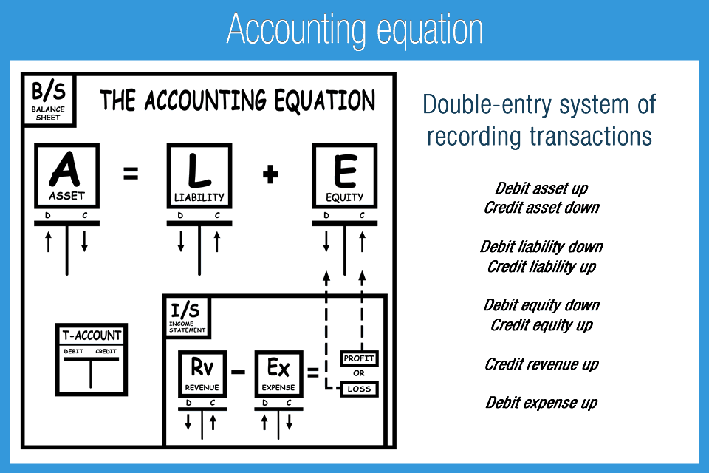
Every accounting transaction involves at least one debit and one credit. The sum of debits and the sum of credits for each transaction and the total of all transactions are always equal. A list of all transactions appears in the general ledger. Debits are always presented before credits.

How to increase and decrease different account types
Increases and decreases of the same account type are common with assets. A business may decide to use money to buy equipment. Cash assets will decrease and equipment assets will increase. Transfers from one cash account to another are also recorded in the same category, but in separate sub-accounts.
In accounting, asset increases are recorded with a debit. Asset decreases are recorded with a credit. (Do not confuse this concept with checking accounts that use these terms differently). Asset accounts, especially cash, are constantly moving up and down with debits and credits.
Memorize rule: Debit asset up, credit asset down
In accounting, expense increases are recorded with a debit and decreases are recorded with a credit. This is the same debit and credit rule order as assets. Transactions to the expense account will be mostly debits unless there is a return of an expense or correction of an error.
Memorize rule: Debit expense up, credit expense down
Every account is classified in one of five different classifications: Assets, liabilities, equity, revenue, and expense. Each account is increased or decreased with a debit or credit depending on the classification.
Memorize rule: Debit liability down, credit liability up
Memorize rule: Debit equity down, credit equity up
Memorize rule: Debit revenue down, credit revenue up

Example accounting entries
Let’s look at how we would make the accounting entries for the following example: Receive $1,000 of revenue and pay $200 for the phone bill.
Entries:
Increase cash: Debit cash $1,000
Increase revenue: Credit revenue $1,000
Increase expense: Debit expense $200
Decrease cash: Credit cash $200
The debits and credits are totaled for each account and then canceled out. This process “nets” or “cancels” the sum of debits and credits for each account to determine the final balance. Say $1,000 of cash is received (debit asset up) and $200 was paid (credit asset down). The resulting account balance for cash will be $800: $1,000 debit – $200 credit.
Accounting is a rule-based system that requires memorization of the debits and credits system. Proper memorization and application of the basic concepts is invaluable when moving to more difficult concepts. Solid understanding of debits and credits is necessary for a student, CPA exam taker, and accounting professional.

T-Accounts
To help visually represent debit and credit entries, a T-account may be used. This is visually represented in Accounting Game – Debits and Credits as a big green T. The left side of the T-account is a debit and the right side is a credit. Actual debit and credit transactions will be recorded in the general ledger, which accumulates all of the transactions, by account. T-accounts help both students and professionals understand accounting adjustments, which are then made with journal entries.
Memorize rule: Debits on the left and credits on the right
Debits and credits follow the logic of the accounting equation: Assets = Liabilities + Equity. At all times Asset debits = Liability credits + Equity credits.
Memorize rule: Assets = Liabilities + Equity
Memorize rule: The sum of all assets will equal the sum of Liabilities + Equity
Each account type will have an ending debit balance or credit balance depending on the account type, generally speaking. Assets and expenses both increase with a debit and therefore have debit ending balances. Liabilities, equity, and revenue increase with a credit and therefore have credit ending balances. A company with a debit balance in equity, also referred to as an accumulated loss, has likely had losses at some point on the income statement.
Memorize rule: Assets and expenses increase with a debit and generally have ending debit balances
Memorize rule: Liabilities, equity, and revenue increase with a credit and generally have credit ending balances
The following table clearly illustrates if an account should be debited or credited with an increase or decrease in its balance.

Account | Increase in Value | Decrease in Value
Assets | Debit | Credit
Liability | Credit | Debit
Equity | Credit | Debit
Revenue | Credit | Debit
Expense | Debit | Credit

